**DESIGN LAYOUT:**

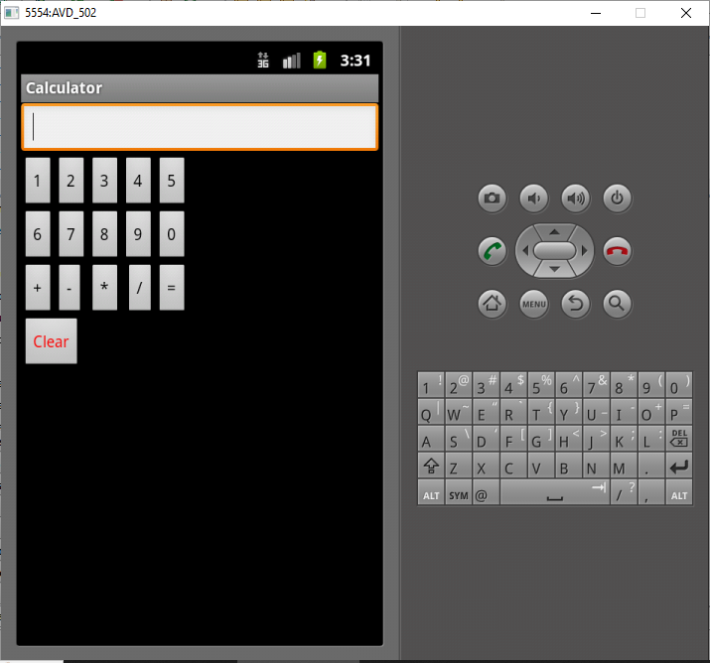

**XML CODING:**

<?xml version=*"1.0"* encoding=*"utf-8"*?>

<LinearLayout xmlns:android=*"http://schemas.android.com/apk/res/android"*

android:layout_width=*"fill_parent"*

android:layout_height=*"fill_parent"*

android:orientation=*"vertical"* >

<RelativeLayout

android:id=*"@+id/relativeLayout1"*

android:layout_width=*"match_parent"*

android:layout_height=*"match_parent"* >

<EditText

android:id=*"@+id/editText1"*

android:layout_width=*"wrap_content"*

android:layout_height=*"wrap_content"*

android:layout_alignParentLeft=*"true"*

android:layout_alignParentRight=*"true"*

android:layout_alignParentTop=*"true"* />

<Button

android:id=*"@+id/button1"*

android:layout_width=*"wrap_content"*

android:layout_height=*"wrap_content"*

android:layout_alignParentLeft=*"true"*

android:layout_below=*"@+id/editText1"*

android:text=*"1"* />

<Button

android:id=*"@+id/button2"*

android:layout_width=*"wrap_content"*

android:layout_height=*"wrap_content"*

android:layout_below=*"@+id/editText1"*

android:layout_toRightOf=*"@+id/button1"*

android:text=*"2"* />

<Button

android:id=*"@+id/button3"*

android:layout_width=*"wrap_content"*

android:layout_height=*"wrap_content"*

android:layout_alignTop=*"@+id/button2"*

android:layout_toRightOf=*"@+id/button2"*

android:text=*"3"* />

<Button

android:id=*"@+id/button4"*

android:layout_width=*"wrap_content"*

android:layout_height=*"wrap_content"*

android:layout_alignTop=*"@+id/button3"*

android:layout_toRightOf=*"@+id/button3"*

android:text=*"4"* />

<Button

android:id=*"@+id/button6"*

android:layout_width=*"wrap_content"*

android:layout_height=*"wrap_content"*

android:layout_alignParentLeft=*"true"*

android:layout_below=*"@+id/button1"*

android:text=*"6"* />

<Button

android:id=*"@+id/button7"*

android:layout_width=*"wrap_content"*

android:layout_height=*"wrap_content"*

android:layout_alignTop=*"@+id/button6"*

android:layout_toRightOf=*"@+id/button6"*

android:text=*"7"* />

<Button

android:id=*"@+id/button8"*

android:layout_width=*"wrap_content"*

android:layout_height=*"wrap_content"*

android:layout_alignTop=*"@+id/button7"*

android:layout_toRightOf=*"@+id/button7"*

android:text=*"8"* />

<Button

android:id=*"@+id/button9"*

android:layout_width=*"wrap_content"*

android:layout_height=*"wrap_content"*

android:layout_alignLeft=*"@+id/button4"*

android:layout_alignTop=*"@+id/button8"*

android:text=*"9"* />

<Button

android:id=*"@+id/button5"*

android:layout_width=*"wrap_content"*

android:layout_height=*"wrap_content"*

android:layout_below=*"@+id/editText1"*

android:layout_toRightOf=*"@+id/button4"*

android:text=*"5"* />

<Button

android:id=*"@+id/button10"*

android:layout_width=*"wrap_content"*

android:layout_height=*"wrap_content"*

android:layout_below=*"@+id/button4"*

android:layout_toRightOf=*"@+id/button4"*

android:text=*"0"* />

<Button

android:id=*"@+id/BPlus"*

android:layout_width=*"wrap_content"*

android:layout_height=*"wrap_content"*

android:layout_alignParentLeft=*"true"*

android:layout_below=*"@+id/button6"*

android:text=*"+"* />

<Button

android:id=*"@+id/BMinus"*

android:layout_width=*"wrap_content"*

android:layout_height=*"wrap_content"*

android:layout_alignTop=*"@+id/BPlus"*

android:layout_toRightOf=*"@+id/BPlus"*

android:text=*"-"* />

<Button

android:id=*"@+id/BStar"*

android:layout_width=*"wrap_content"*

android:layout_height=*"wrap_content"*

android:layout_alignLeft=*"@+id/button8"*

android:layout_alignTop=*"@+id/BMinus"*

android:text=*"*"* />

<Button

android:id=*"@+id/BSlash"*

android:layout_width=*"wrap_content"*

android:layout_height=*"wrap_content"*

android:layout_alignTop=*"@+id/BStar"*

android:layout_toLeftOf=*"@+id/button10"*

android:text=*"/"* />

<Button

android:id=*"@+id/BEqual"*

android:layout_width=*"wrap_content"*

android:layout_height=*"wrap_content"*

android:layout_alignLeft=*"@+id/button10"*

android:layout_alignTop=*"@+id/BSlash"*

android:text=*"="* />

<Button

android:id=*"@+id/button11"*

android:layout_width=*"wrap_content"*

android:layout_height=*"wrap_content"*

android:layout_alignParentLeft=*"true"*

android:layout_below=*"@+id/BPlus"*

android:text=*"Clear"*

android:textColor=*"#ff0000"*/>

</RelativeLayout>

</LinearLayout>

**JAVA CODING:**

package com.Calculator;

import android.app.Activity;

import android.os.Bundle;

import android.view.View;

import android.widget.Button;

import android.widget.EditText;

public class CalculatorActivity extends Activity {

EditText box;

Button b1,b2,b3,b4,b5,b6,b7,b8,b9,b0,badd,bsub,bmul,bdiv,beql,bclr;

double num1,num2,result;

String option;

@Override

public void onCreate(Bundle savedInstanceState) {

super.onCreate(savedInstanceState);

setContentView(R.layout.main);

box=(EditText)findViewById(R.id.editText1);

b1=(Button)findViewById(R.id.button1);

b2=(Button)findViewById(R.id.button2);

b3=(Button)findViewById(R.id.button3);

b4=(Button)findViewById(R.id.button4);

b5=(Button)findViewById(R.id.button5);

b6=(Button)findViewById(R.id.button6);

b7=(Button)findViewById(R.id.button7);

b8=(Button)findViewById(R.id.button8);

b9=(Button)findViewById(R.id.button9);

b0=(Button)findViewById(R.id.button10);

badd=(Button)findViewById(R.id.BPlus);

bsub=(Button)findViewById(R.id.BMinus);

bmul=(Button)findViewById(R.id.BStar);

bdiv=(Button)findViewById(R.id.BSlash);

beql=(Button)findViewById(R.id.BEqual);

bclr=(Button)findViewById(R.id.button11);

b1.setOnClickListener(new View.OnClickListener() {

public void onClick(View v) {

box.append("1");

}

});

b2.setOnClickListener(new View.OnClickListener() {

public void onClick(View v) {

box.append("2");

}

});

b3.setOnClickListener(new View.OnClickListener() {

public void onClick(View v) {

box.append("3");

}

});

b4.setOnClickListener(new View.OnClickListener() {

public void onClick(View v) {

box.append("4");

}

});

b5.setOnClickListener(new View.OnClickListener() {

public void onClick(View v) {

box.append("5");

}

});

b6.setOnClickListener(new View.OnClickListener() {

public void onClick(View v) {

box.append("6");

}

});

b7.setOnClickListener(new View.OnClickListener() {

public void onClick(View v) {

box.append("7");

}

});

b8.setOnClickListener(new View.OnClickListener() {

public void onClick(View v) {

box.append("8");

}

});

b9.setOnClickListener(new View.OnClickListener() {

public void onClick(View v) {

box.append("9");

}

});

b0.setOnClickListener(new View.OnClickListener() {

public void onClick(View v) {

box.append("0");

}

});

badd.setOnClickListener(new View.OnClickListener() {

public void onClick(View v) {

num1=Double.parseDouble(box.getText().toString());

box.setText("");

option="+";

}

});

bsub.setOnClickListener(new View.OnClickListener() {

public void onClick(View v) {

num1=Double.parseDouble(box.getText().toString());

box.setText("");

option="-";

}

});

bmul.setOnClickListener(new View.OnClickListener() {

public void onClick(View v) {

num1=Double.parseDouble(box.getText().toString());

box.setText("");

option="*";

}

});

bdiv.setOnClickListener(new View.OnClickListener() {

public void onClick(View v) {

num1=Double.parseDouble(box.getText().toString());

box.setText("");

option="/";

}

});

beql.setOnClickListener(new View.OnClickListener() {

public void onClick(View v) {

if(option.equals("+"))

{

num2=Double.parseDouble(box.getText().toString());

result=num1+num2;

box.setText(String.valueOf(result));

}

if(option.equals("-"))

{

num2=Double.parseDouble(box.getText().toString());

result=num1-num2;

box.setText(String.valueOf(result));

}

if(option.equals("*"))

{

num2=Double.parseDouble(box.getText().toString());

result=num1*num2;

box.setText(String.valueOf(result));

}

if(option.equals("/"))

{

num2=Double.parseDouble(box.getText().toString());

if(num2==0)

{

box.setText("Zero Division Error");

}

else

{

result=num1/num2;

box.setText(String.valueOf(result));

}

}

}

});

bclr.setOnClickListener(new View.OnClickListener() {

public void onClick(View v) {

num1=0;

num2=0;

result=0;

box.setText("");

}

});

}

}

**OUTPUT:**

